 

Before proceeding to install Exerp you will need the following;

1. Administrator access on your computer – This is required to install Exerp.
2. A client code for the Exerp installation – If you do not have one prior to this installation please raise a ticket with the Service Desk to request one.
3. Internet access on your computer
4. Google Chrome web browser (or any other available web browser; Microsoft Edge, Firefox etc)
5. A staff profile in Exerp with a valid username and password
   1. Username can be either your email address within your member profile in Exerp or your staff login ID. Example of a staff login; 100emp1001.

To install Exerp for the first time you will require the Exerp Installer. You can download this installer from the links below but depending on which environment you need will determine which link you use.

There are 2 links to choose from;

1. **PRODUCTION:** <https://fernwood.exerp.com/dist/>
   1. This is the link for the Production environment. This is the live environment with live member data and billing. This will be always be used once you are live with Exerp in your club. The production environment is purple in colour as per the example below;
   2. 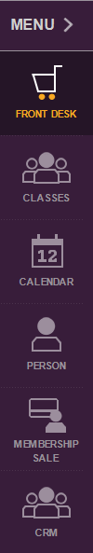
2. When you have selected the link based on the environment you require, copy and paste it into your browser (chrome is preferred, however, any browser should work).
   1. When you have loaded the link in your browser you will see the below;

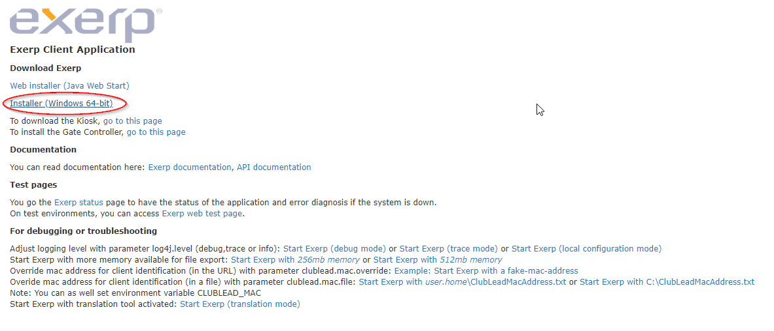

* 1. Click on ‘Installer (Windows 64-bit)’ that is circled in red. Once clicked, your file will begin downloading. Depending on your internet connection and speed, download time will vary. The file is around 320mb so please allow up to 15 minutes download time.
  2. Navigate to your downloads folder (this may be different from pc to pc). Usually the default location is; **C:\Users\your pc user name\Downloads**. You will see a file called ‘exerp-x86_64fernwood.exe or exerp-x86_64fernwood-test.exe depending on which file you downloaded.
  3. Files should look like the below;





* 1. Right click on the file and select ‘run as administrator’

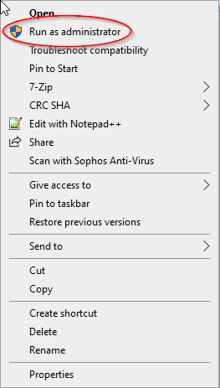

* 1. When this loads, you may see the below error. If you do, do not be alarmed, this is normal. You will only ever see this if it is the very first time running this installation process.

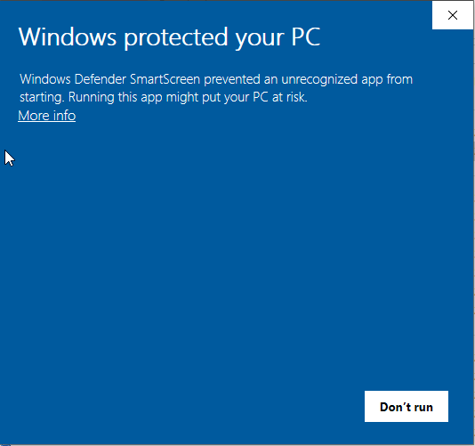

* 1. Click ‘more info’ and then click ‘Run anyway’.

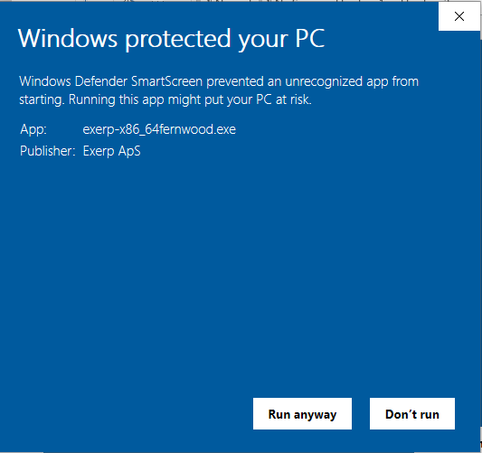

* 1. You will be present with this window. Click ‘next’.

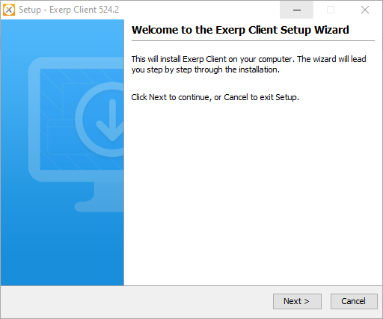

* 1. You will not be required to copy and paste your client code.

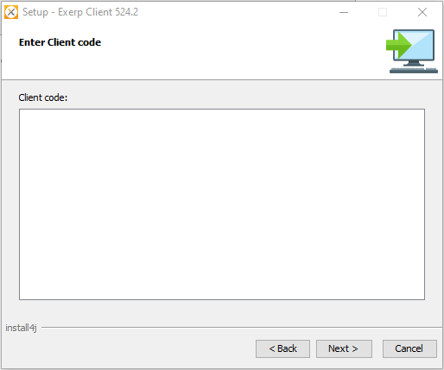

* 1. Select ‘Is for all users on this computer’. Once select, click next.

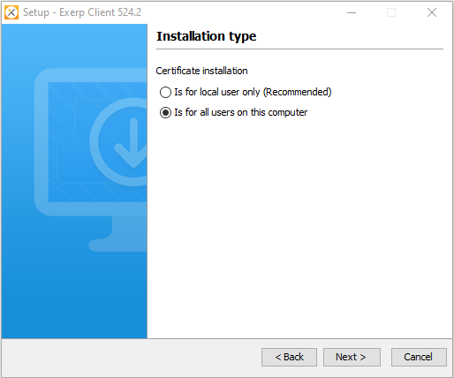

* 1. Nothing is required here other than to click Next.

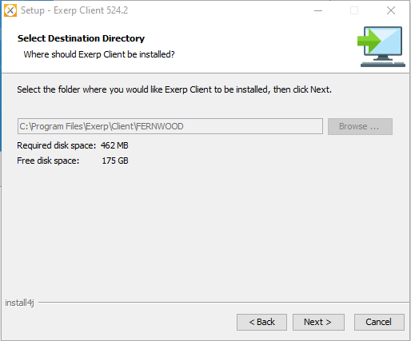

* 1. Nothing is required here other than to click Next.

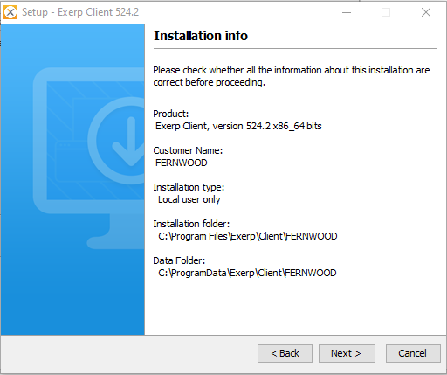

* 1. Wait for the installation to complete.

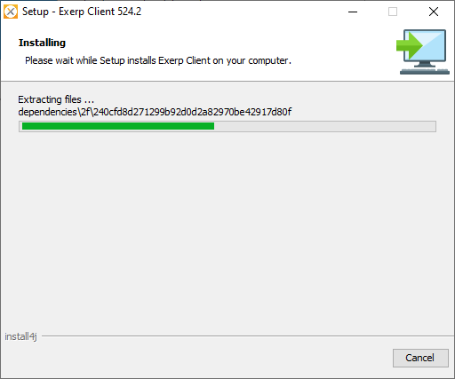

* 1. Click finish to complete the installation. Exerp is now installed!

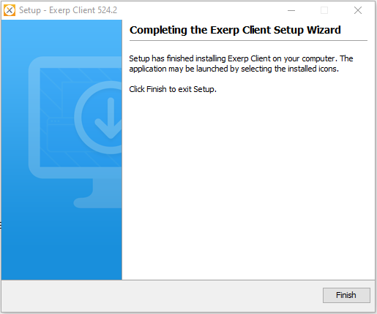

1. Once finished, the Exerp client creation wizard window will open. Click Next
   1. You will be prompted to enter your username and password

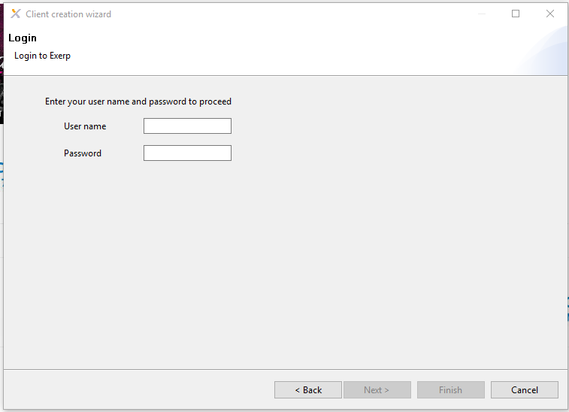

* 1. You will see default values with your club and Computer Name. Click Next

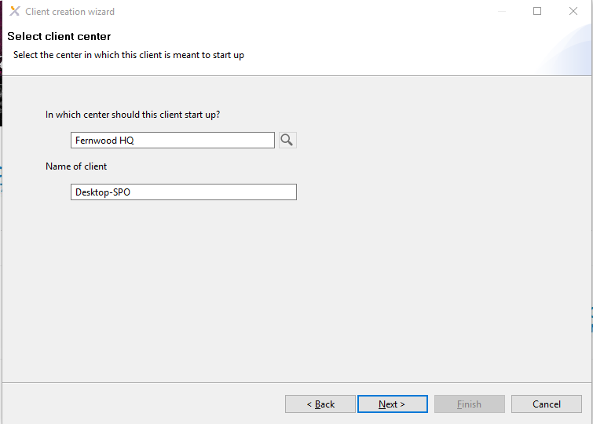

* 1. If your computer is a POS computer then select Cash Register, otherwise select If this PC is a POS PC please select Cash Register, otherwise no Cash Register should be selected.

Please Note: Cash registers are only required if you enter sales within Exerp (New members, Food and Beverage or Merchandise).

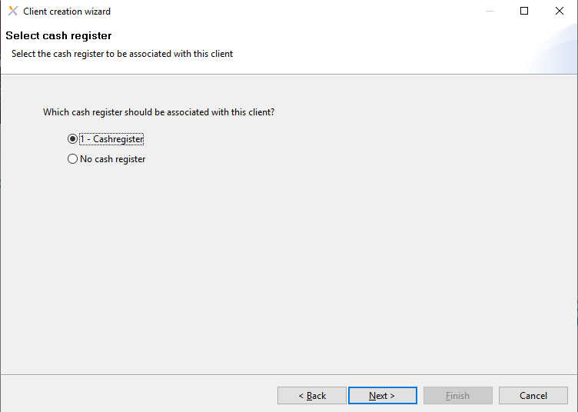

1. You Exerp installation is complete. We will now need to setup your desktop shortcut.
   1. Search for ‘Exerp’ within the windows start menu
   2. Right click on the icon and click ‘open file location’

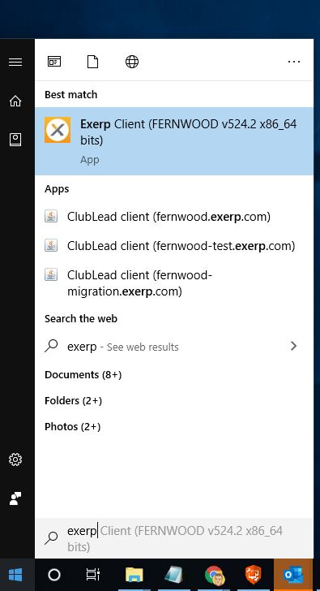

* 1. Once you see the file location. Right click and select ‘Send to’ and then ‘Desktop (create shortcut)

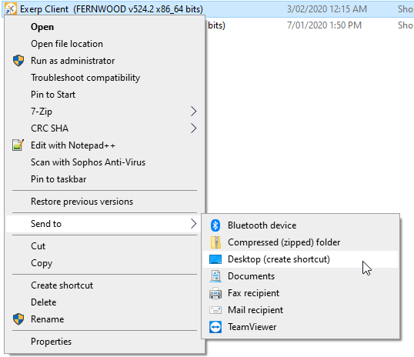

* 1. This will then create a short on the desktop which you will use to run Exerp.
     1. Right click on the icon and select ‘rename’

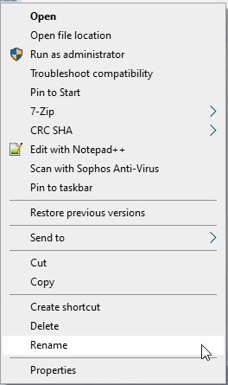

* + 1. Rename the shortcut to ‘EXERP – PRODUCTION’ or ‘EXERP – TEST’ depending on which environment you have installed.

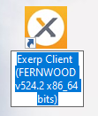

* + 1. Your file should now be renamed

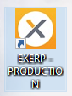

1. Exerp installation is now complete.

 

Logging into Exerp for the first time will require you to have your username and password.

If you do not have a username or password please raise a ticket with the service desk to request one.

1. Open Exerp
   1. The login screen will load

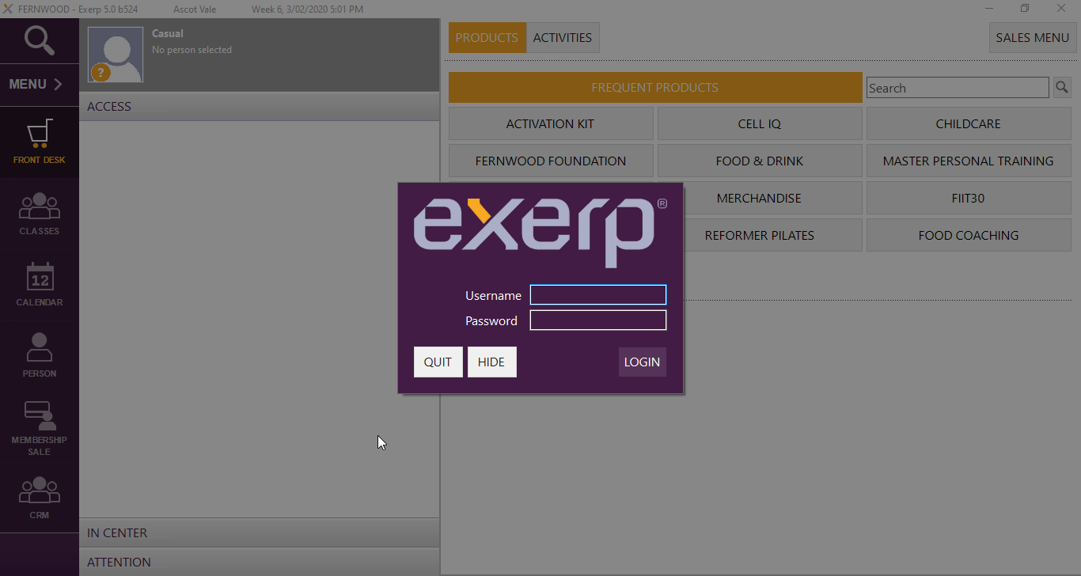

* 1. Enter your username and password
     1. Your username is either your login ID or email address
        1. Please Note: In order to user your email address it needs to be added on your member profile in Exerp.

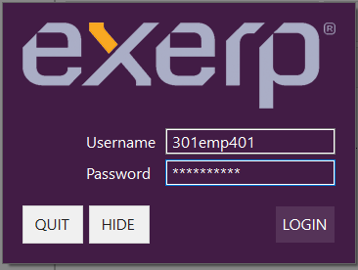 OR 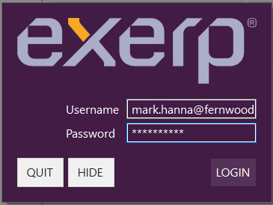

* + 1. If it is your first-time logging in you will be required to change your password upon successful login
       1. Enter your new password and confirm it

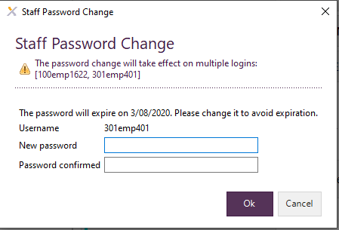

* + - 1. Once your password is confirmed and you click OK Exerp will automatically log you in

**IMPORTANT:** Log out immediately. Log back in using your newly updated password. Failing to do this step will result in your account being locked out for 30 minutes.

Login Tips;

1. You can use either your login ID or email address to login
2. As a shortcut to login you can use the last 3 digits in your login ID.
   1. Example: If you staff login is 301emp401 you can use only ‘401’ as the username
3. If you have a login for more than one club your password will be the same for all your logins